LATINO/HISPANIC PARENT /GUARDIAN CONFERENCE

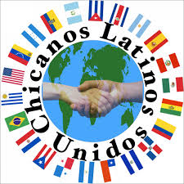

Monday, February 9, 2015 4:00 pm-5:30 pm
Olympic High School Multi-purpose Room
Free Refreshments/Beverages/Snacks Free Child Care Provided

All Latino/Hispanic parents or guardians are invited to attend a Conference to celebrate and support Latino/Hispanic students’ academic achievements. The goal is to give parents or guardians an opportunity to celebrate students’ academic success. Please, if you have comments or questions contact Mr. Lopes (925)687-0363 ext. 3000 or LopesM@MDUSD.org

