Community Night Meeting
When: November 13, 2014
Time: 5:30-6:30
Where: Olympic High School, Multi- Purpose Room
Snacks and Refreshments will be provided
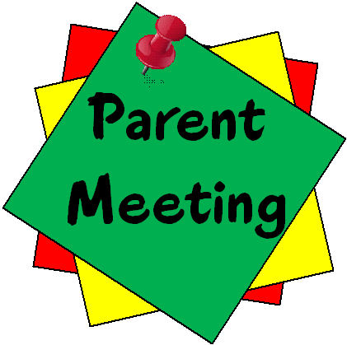
Community will be talking about how the school year is going. Also administrators and community members will together to maintain a safe school.

